How to share your prototypes with anyone
Ten platforms, and how to get a link into someone else’s hands
Every platform below works the same way underneath. You either invite a specific person by email, which gives them a named account and a role, or you turn on a general link that anyone can open. Invites are safer; links are faster. Part 1 covers tools where you grant access to existing work. Part 2 covers tools where you publish first and the link is the share.

PART 1 • GIVING PEOPLE ACCESS TO YOUR WORK

1. Figma
- Open the file you want to share.
- Click the Share button in the top right corner.
- To invite a person, type their email in the invite field and pick can view or can edit.
- To share broadly, change the link setting from Only people invited to Anyone with the link, then choose can view.
- Click Copy link to send it, or Send invite to email the named people.
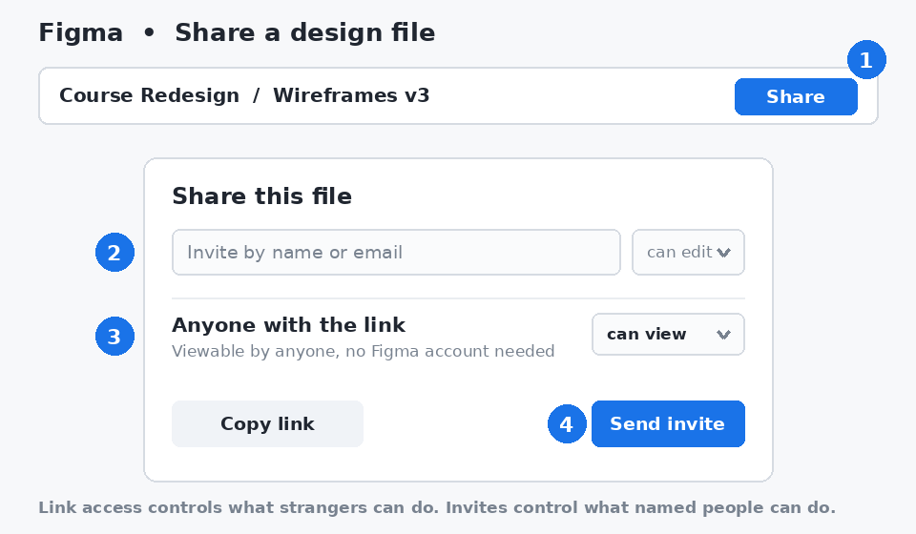
The Figma share dialog: invite named people at the top, set link access below.
Share with anyone: Set the link to "Anyone with the link" and "can view." The person does not need a Figma account to open it. Use "can edit" only for people you trust with the file.

2. Justinmind
- In the editor, click the Share icon in the top toolbar to publish the project to your Justinmind cloud account.
- From the Home dashboard, open My projects, right-click the project, and choose Share.
- In the Share with editors and viewers dialog, pick Can view for reviewers or Can edit for co-designers.
- Type the email addresses of the people you want to add, then confirm. They receive an email with a link.
- For a link, right-click the project and choose Get link, or use the link option at the bottom of the share dialog.
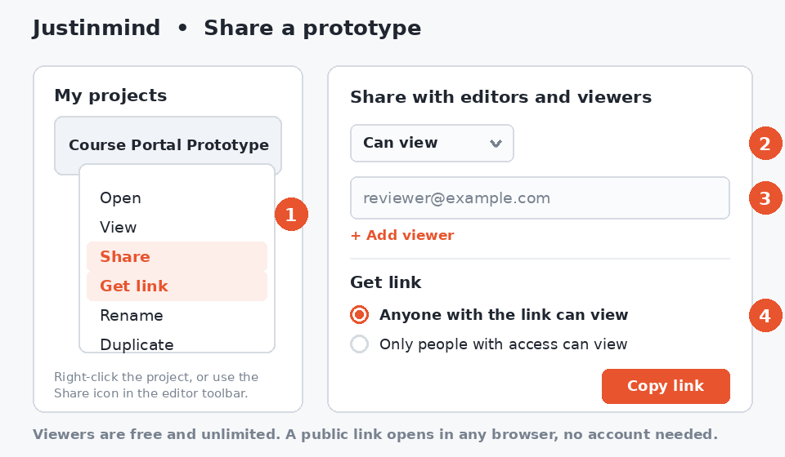
Right-click the project to Share or Get link, then set the permission in the dialog.
Share with anyone: In the Get link dialog, choose "Anyone with the link can view." The prototype then opens in any browser with no Justinmind account required. Viewers are free and unlimited, so inviting reviewers by email costs nothing either.

3. SharePoint and OneDrive
- Open the site or library, hover over the file or folder, and click Share.
- Click the current link setting at the top of the dialog, such as People in your organization.
- Choose who the link is for: Anyone with the link, People in your organization, or Specific people.
- Set Can edit or Can view, and optionally add an expiry date or password.
- Click Apply, then either enter email addresses and click Send, or click Copy link.
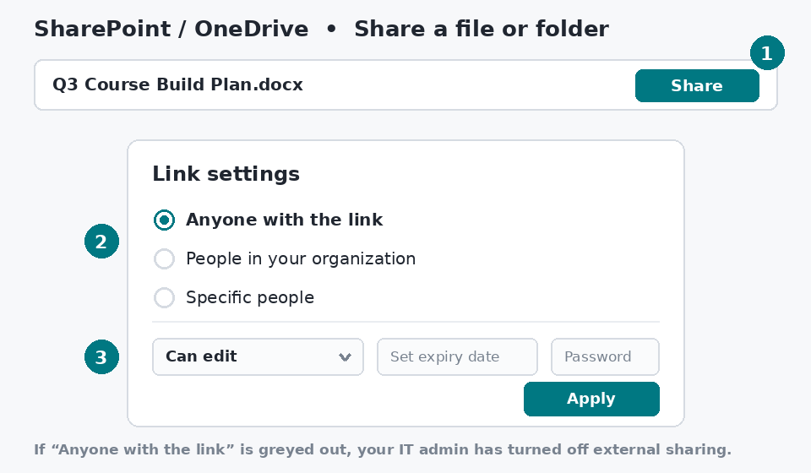
The SharePoint link settings dialog controls who the link works for.
Share with anyone: Choose "Anyone with the link" and set it to Can view. If that option is greyed out, external sharing is blocked by your IT admin, so use "Specific people" and enter the person's email instead.

4. GitLab
- Open the project you want to share.
- In the left sidebar, select Manage, then Members.
- Click Invite members.
- Enter a GitLab username, or an email address if the person does not have an account yet.
- Choose a role, such as Guest for view only or Developer for contributors, add an optional expiration date, then click Invite.
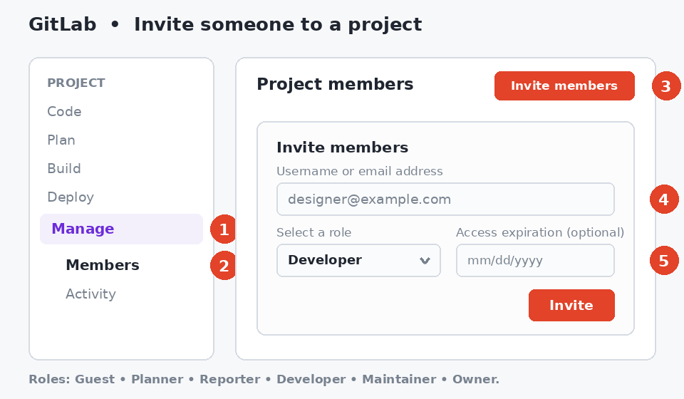
Manage, then Members, then Invite members. The role decides what the person can do.
Share with anyone: For view only access without an invite, go to Settings, then General, then Visibility, and set the project to Public. Anyone can then browse it from the URL. Otherwise, invite them by email and GitLab will prompt them to create a free account.

5. GitHub
- Open the repository and click the Settings tab.
- In the Access section of the left sidebar, click Collaborators.
- Click Add people.
- Search by username, full name, or email, then select the right person.
- Pick a role such as Read, Write, or Admin, then confirm. The person receives an email invitation they must accept.
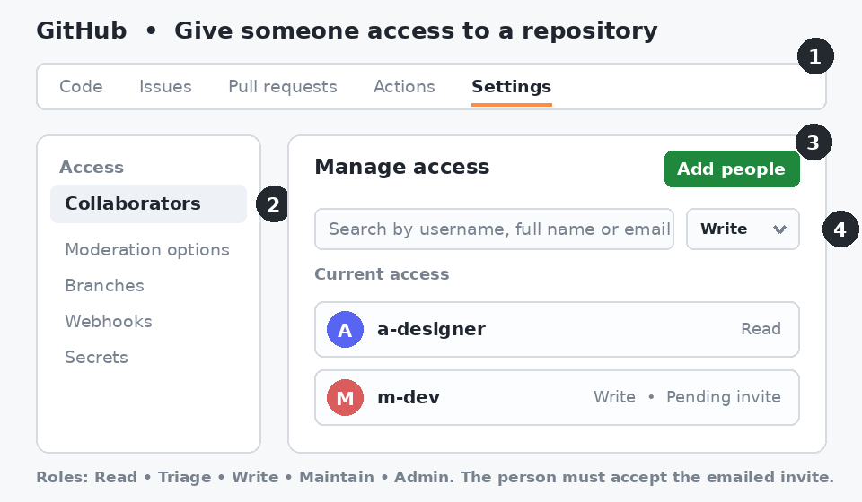
Settings, then Collaborators, then Add people. Pending invites show until accepted.
Share with anyone: A Public repository is already visible to everyone, so you can just send the URL. For a Private repository there is no public link, so each person needs a GitHub account and an accepted invitation. Note that on a personal private repo, collaborators get write access; use an organization if you need read only.

PART 2 • PUBLISHING TO A PUBLIC WEB ADDRESS
These five are less about permissions and more about publishing. In each case the work sits in a private editor until you press a button, and only then does a public web address exist. The link is the sharing mechanism, so the main decisions are what the address says and whether you gate it.

6. Vercel
- Deploy the project, either by connecting a Git repository or by running the Vercel CLI. Each deployment gets its own address ending in .vercel.app.
- Open the project in the Vercel dashboard and find the deployment you want to share.
- For a production deployment, copy the URL and send it. It is public unless you turned on Deployment Protection.
- For a protected or preview deployment, click Share next to the deployment, set the dropdown to Anyone with the link, then click Copy Link.
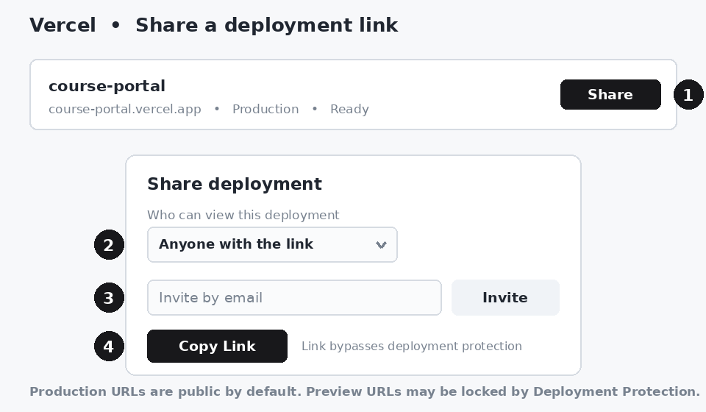
The Share popover creates a link that bypasses Deployment Protection.
Share with anyone: The production URL is already public, so the URL itself is the share. Use a Shareable Link only when protection is on. To revoke it later, switch the dropdown back to Only people with access.

7. Google Sites
- Open the site at sites.google.com and click Publish in the top right.
- Under Web address, type the name you want. The site will live at sites.google.com/view/your-name.
- Click Manage and set who can view the published site: Public, or Restricted for named people only. Then click Publish.
- To change it later, or to add editors, click the Share icon and adjust the Published and Draft settings separately.
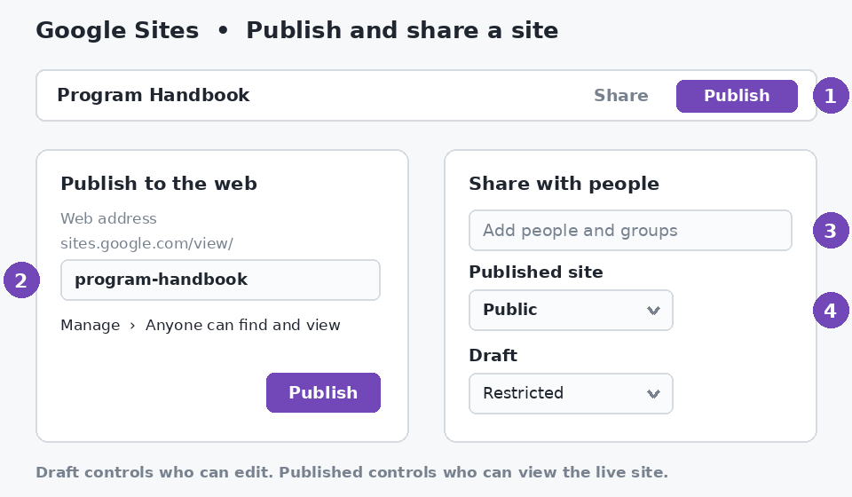
Publish sets the address. Share controls who can view the published site and who can edit the draft.
Share with anyone: Set the published site to Public, then send the sites.google.com/view/ address. If your account is managed by a school or employer, Public may be limited to people inside the organization.

8. PowerPoint as a link
- Save the deck to OneDrive or SharePoint. A file sitting only on your computer cannot have a link.
- Click Share in the top right of PowerPoint, or use File, then Share.
- Click the current permission line and set it to Anyone with the link, with Can view unless you want edits.
- Click Copy link and paste it wherever you need, or enter email addresses and click Send.
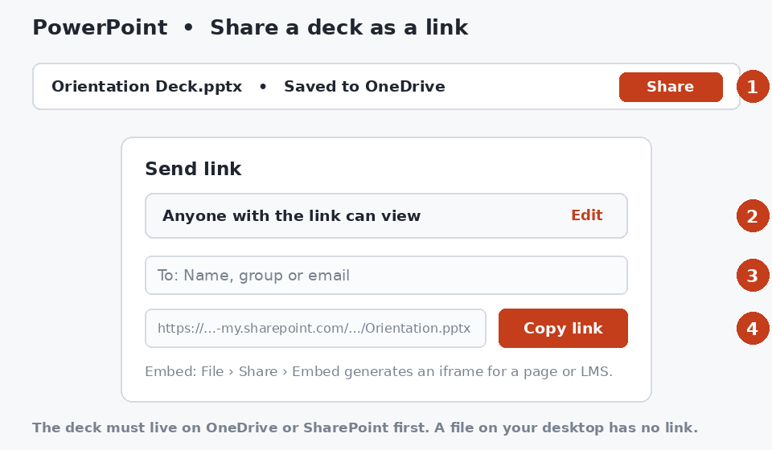
PowerPoint uses the same link settings as SharePoint and OneDrive underneath.
Share with anyone: Choose "Anyone with the link" and Can view. The recipient opens the deck in PowerPoint for the web with no Microsoft account and no software needed. To put it inside a page or an LMS, use File, then Share, then Embed to get an iframe.

9. Wix
- In the editor, click Publish. A free site goes live at yourname.wixsite.com/sitename.
- Copy that address from the confirmation message or from Settings in your site dashboard, then send it to anyone.
- To let someone help build the site, open the site dashboard, go to Settings, then Roles & Permissions.
- Click Invite Collaborators, enter their email addresses, tick a role such as Website Manager, and click Send Invites.
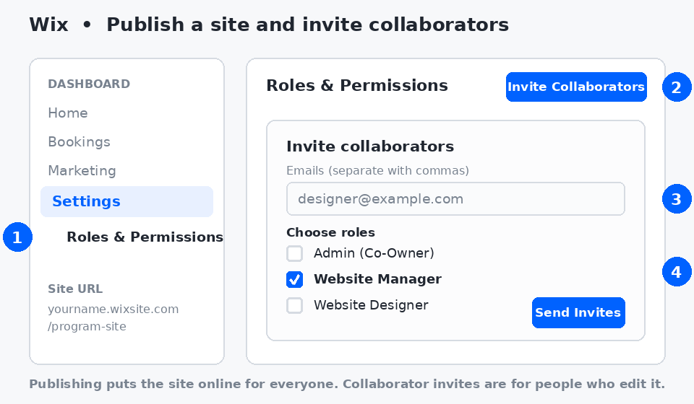
Publishing makes the site public. Roles and Permissions controls who can edit it.
Share with anyone: Publishing is the share. Anyone can visit the wixsite.com address without an account. Note that free Wix sites include Wix branding and a standard plan comes with only one free collaborator seat.

10. Weebly
- In the editor, open Settings, then General, and check the Site Address. A free site uses a subdomain such as yourname.weebly.com.
- Click Publish in the top right. Weebly confirms the site is live and shows the address.
- Copy that address and share it with anyone. No account is needed to visit it.
- Republish after every round of edits, or visitors will keep seeing the previous version.
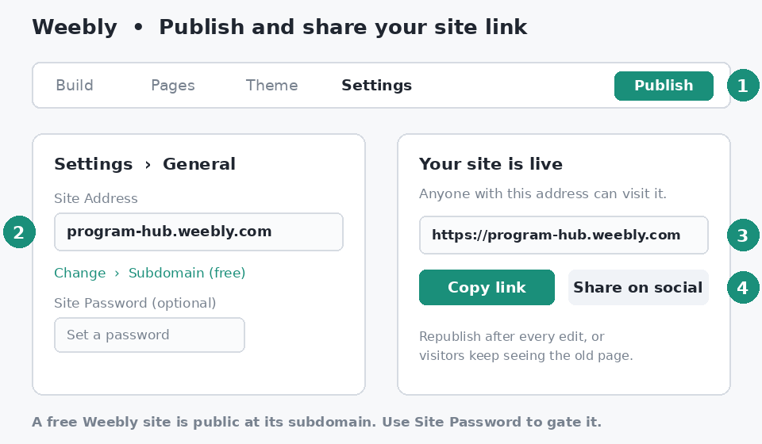
Settings sets the address; Publish puts it live at that address.
Share with anyone: The published subdomain is public to anyone who has it. If the site is not ready for the world, set a Site Password under Settings, then General, and give the password only to your reviewers.

